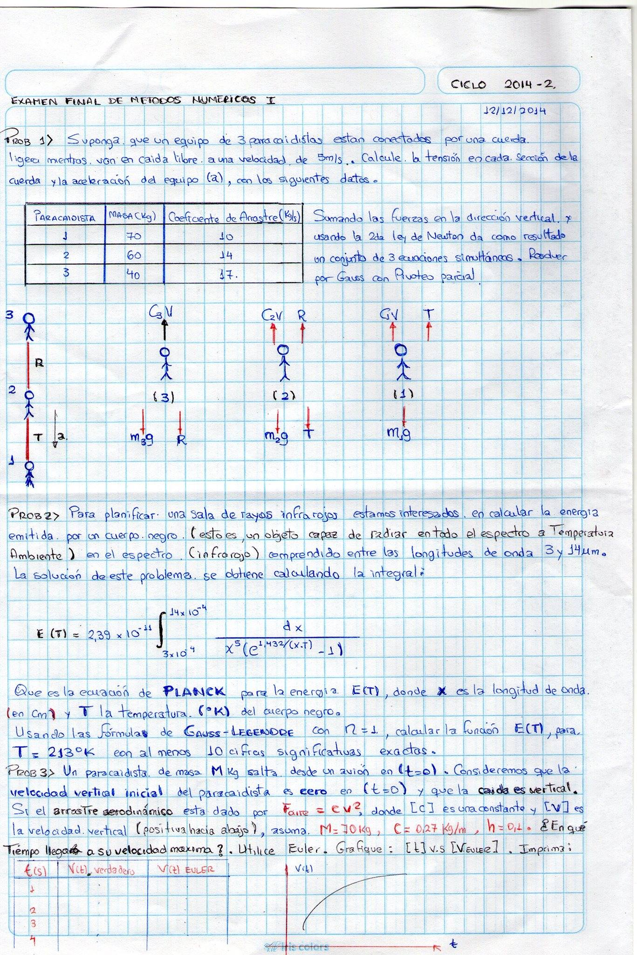 Cristhian tuni castro

SOLUCION

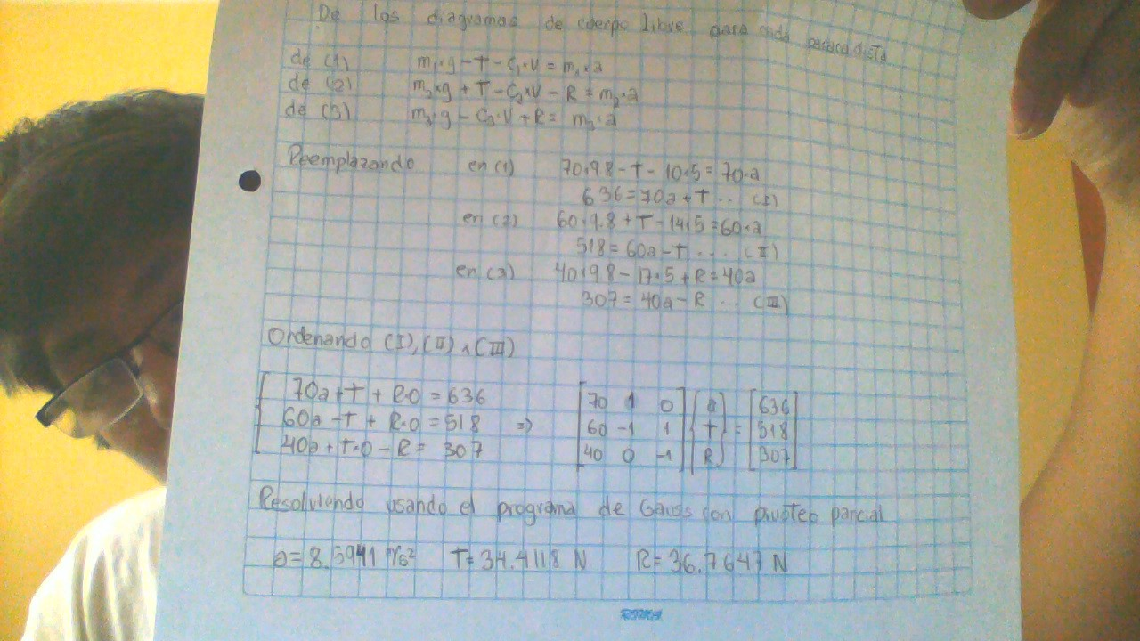

Programa de gaus pivoteo parcial

function x=sustitucion(a,b,n)

x(n)=b(n)/a(n,n);

for i=n-1:-1:1

sum=0;

for j=i+1:n

sum=sum+a(i,j)\*x(j);

end

x(i)=(b(i)-sum)/a(i,i);

end

end

function [a,b,er,f]=eliminacion(a,b,n,tol,s,er)

u=1;

for k=1:n-1

[a,b]=pivot(a,b,n,s,k);

if abs(a(k,k)/s(k))<tol

er=-1;

break

end

for i=k+1:n

f(u)=a(i,k)/a(k,k);

for j=1:n

a(i,j)=a(i,j)-f(u)\*a(k,j);

end

b(i)=b(i)-f(u)\*b(k);

u=u+1;

end

end

if abs(a(n,n)/s(n))<tol

er=-1;

end

function [x]=gauss(a,b,tol)

er=0;

n=length(b);

s=zeros(1,n);

for i=1:n

s(i)=abs(a(i,1));

for j=2:n

if abs(a(i,j))>s(i)

s(i)=abs(a(i,j));

end

end

end

[a,b,er,f]=eliminacion(a,b,n,tol,s,er);

if er~=-1

x=sustitucion(a,b,n);

end

end

function [a,b]=pivot(a,b,n,s,k)

p=k;

big=abs(a(k,k)/s(k));

for z=k+1:n

t=abs(a(z,k)/s(z));

if t>big

big=t;

p=z;

end

end

if p~=k

for w=k:n

t=a(p,w);

a(p,w)=a(k,w);

a(k,w)=t;

end

t=b(p);

b(p)=b(k);

b(k)=t;

t=s(p);

s(p)=s(k);

s(k)=t;

end

end

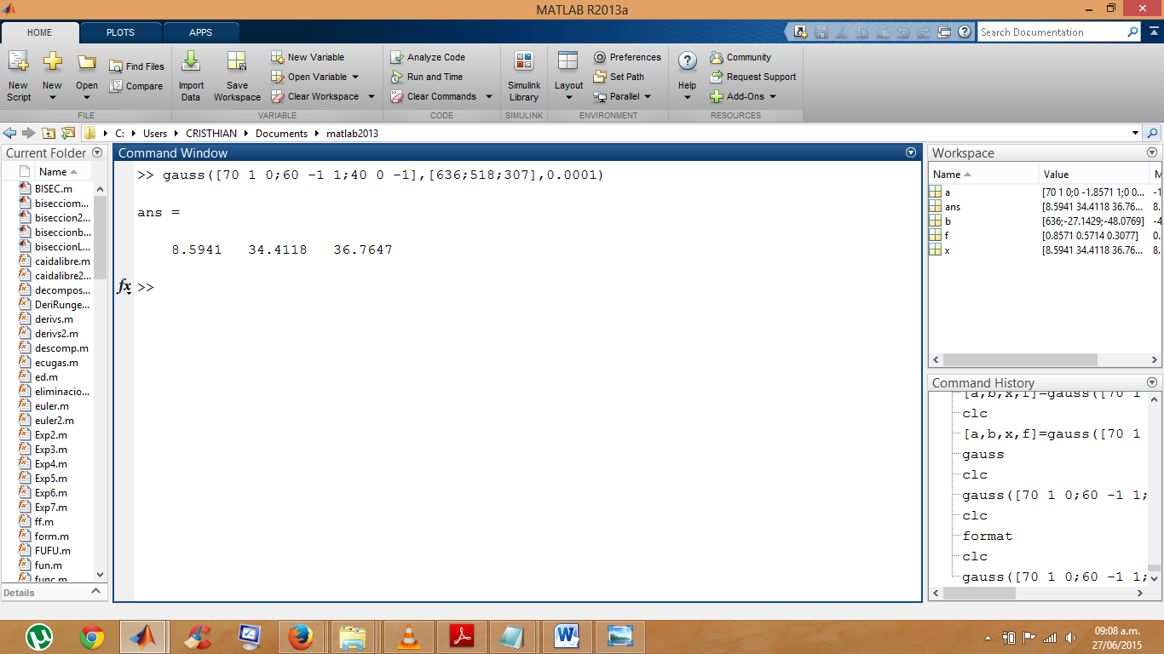compilación del problema